

**MEMORANDUM OF UNDERSTANDING**

This is a document validating an agreement between **MR. OGABOR JOHN AND MRS. OLUREMI WURAOLA AKINLATUN** for the collaborative of 20% interest over a sum of **TWO HUNDRED AND FIFTY THOUSAND NAIRA ONLY (N250,000) paid on the 15th of May, 2020.**

There is a binding agreement to pay the initial capital invested, alongside the interest, **THREE HUNDRED THOUSAND NAIRA ONLY (N300,000) on the 15th of June, 2020** by **MR. OGABOR JOHN TO MRS. OLUREMI WURAOLA AKINLATUN.**

Attached with this document is an evidence of payment by **MRS. OLUREMI WURAOLA AKINLATUN.**

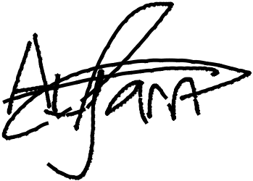

_________________________

_~~__~~_____~~___~~_~~_~~___________



**MRS. OLUREMI WURAOLA AKINLATUN**

**MR. OGABOR JOHN**

***(CEO, JOHN INVESTMENTS)***